How to implement 2.5D graphics?
2.5D graphics refer to a visual style that creates the illusion of three-dimensional depth using two-dimensional techniques. In this document we cover the three main approaches used in game development, and we explain how our game engine implements them for the Racing Roguelike project.
Sources:
https://en.wikipedia.org/wiki/2.5D
https://en.wikipedia.org/wiki/Mode_7
https://en.wikipedia.org/wiki/Ray_casting#Ray_casting_in_early_computer_games
https://github.com/Cubified/mode7?tab=readme-ov-file
2.5D Techniques
Skyboxes and Sky-domes
Skyboxes and sky-domes are methods used to easily create a background to make a game level look bigger than it really is. If the level is enclosed in a cube, the sky, distant mountains, distant buildings, and other unreachable objects are rendered onto the cube's faces using a technique called cube mapping, thus creating the illusion of distant three-dimensional surroundings. A Skydome employs the same concept but uses a sphere or hemisphere instead of a cube.
Scaling along the Z axis
In some games, sprites are scaled larger or smaller depending on their distance to the player, producing the illusion of motion along the Z (forward) axis. This technique is at the core of billboard-based sprite rendering, this is the method we use for rendering karts and other track objects on the engine.
Mode 7
Mode 7 is a graphics mode from the Super Nintendo Entertainment System (SNES) that allows a background layer to be rotated and scaled on a scanline-by-scanline basis to create depth effects. The most well-known application is the perspective effect on a background layer, which transforms it into a two-dimensional horizontal texture-mapped plane that trades height for depth, achieving an impression of three-dimensional graphics.
Mode 7 graphics are generated for each pixel by mapping screen coordinates to background coordinates using an affine transformation:
r' = M(r − r₀) + r₀
Where M is a 2x2 transformation matrix, r is the screen coordinate, and r0 is the origin. This maps every pixel on screen to a corresponding point in the texture of the 2D map.
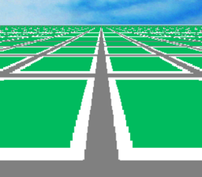
Ray casting
Ray casting is a first-person pseudo-3D technique in which a ray for every vertical slice of the screen is sent from the position of the camera. These rays shoot out until they hit an object or wall, and that part of the wall is rendered in that vertical screen slice. Due to the limited camera movement and internal 2D playing field, this is often considered 2.5D

Our Implementation:
Our engine combines all three techniques described above. The canvas is divided by a horizontal Horizon Line at y = canvasHeight / 2. Everything above this line is the sky, and everything below is the floor rendered with Mode 7-style perspective. In sum, the illusion of depth arises out of the z coordinate of a pixel in 3d space being related to its y coordinate in 2d space, the closer a pixel is to the camera, the larger it will appear in the view window. Additionally, the angle of depression between the camera and a given pixel is also determined by that pixel's y value in 2d space, the farther a given pixel is from the camera, the closer its angle of depression will be to 0.
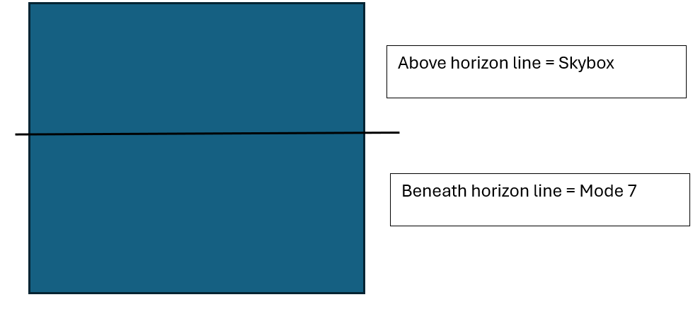
The horizon line and row distance
For every row of pixels below the horizon, we calculate how far that row is from the camera using the following equation:
rowDist = camera.posZ / (y − horizon)
camera.posZ is the virtual height of the camera above the floor. The denominator (y − horizon) is small for rows near the horizon (far away) and large for rows near the bottom of the screen (close to the camera). This gives us correct perspective scaling automatically.

Finding the Left Edge of Each Row
For each row, we find the map coordinate that corresponds to the leftmost pixel using vector scaling:
floorX_step = rowDist × (camera.dirX − camera.planeX)
floorY_step = rowDist × (camera.dirY − camera.planeY)
The expression (dirX − planeX) is the vector pointing to the left corner of the camera's field of view. Multiplying by rowDist scales it to the correct distance in the map, giving us the starting map coordinate for that row.
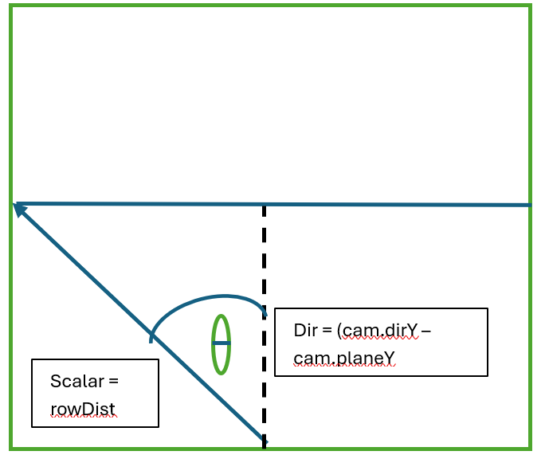

Advancing Across Each Row (Discrete Derivative)
To find the map coordinate for every subsequent pixel in the row, we use a discrete derivative — how much the map coordinate changes per pixel advance:
stepX = rowDist × (2 × camera.planeX) / screenWidth
stepY = rowDist × (2 × camera.planeY) / screenWidth
2 × planeX represents the total width of the camera plane from left edge to right edge. Dividing by screenWidth gives the map distance per pixel. Rows closer to the horizon have a larger rowDist, meaning each pixel covers more map distance, which produces the compression of distant elements seen in perspective rendering.
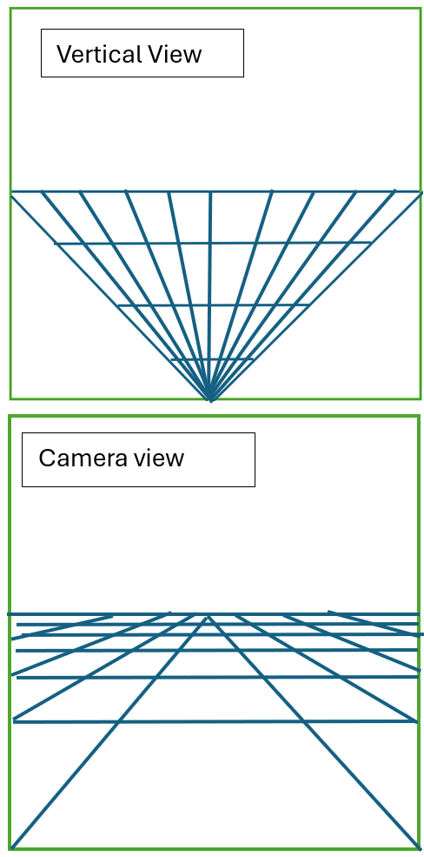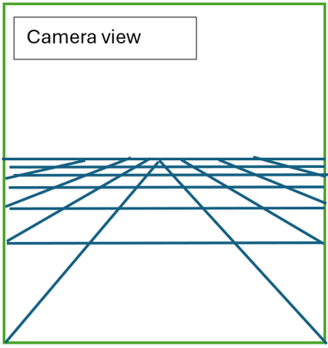

Mapping Floor Coordinates
The final map coordinate for pixel (x, y) is calculated by adding the camera position to the step offset:
floorX = camera.posX + floorX_step
floorY = camera.posY + floorY_step
This translation from origin to camera position is essential, without it, the perspective would be calculated from the world origin (0, 0) rather than from the camera's actual position in the map (big bug I had to solve).

Rendering the Pixel Buffer
With the map coordinate known for each pixel, we sample the texture or grid at that position and write the result directly into the pixel buffer:
for (let x = 0; x < this.width; x++) {
const i = (y * this.width + x) * 4;
pixels[i] = r; // Red
pixels[i+1] = g; // Green
pixels[i+2] = b; // Blue
pixels[i+3] = 255; // Alpha
floorX += stepX;
floorY += stepY;
}
Each pixel occupies 4 consecutive positions in the buffer (RGBA). The index formula (y × width + x) × 4, maps 2D canvas coordinates to a flat array index.

Result
Finally, we can render this picture, we can move freely on this space, and turn around, and see how the squares on the floor distort from us rotating the camera.
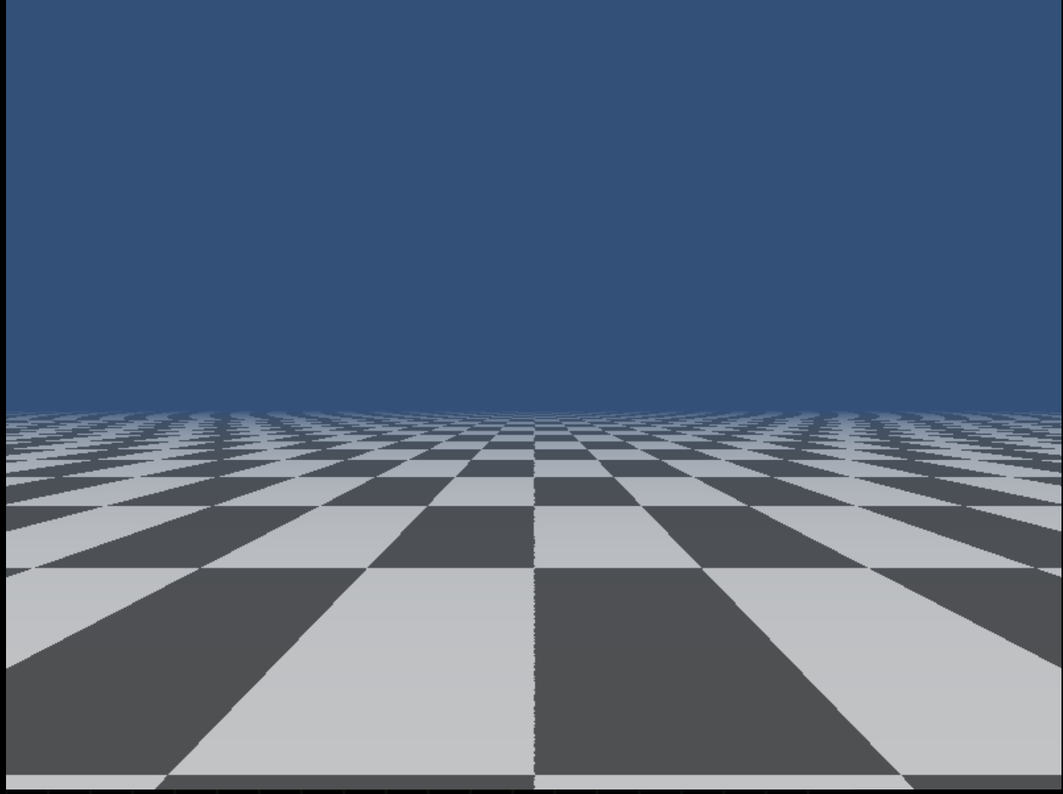

Conclusion
Our 2.5D implementation combines Mode 7-style floor projection, Z-axis sprite scaling, and a sky filling into a unified rendering pipeline. The result is a perspective-correct view of a 2D map that runs efficiently.
The main thing that pushed this engine forward is the formula:
rowDist = posZ / (y − horizon)
This provided a clear showcase of how distortion of perspective arises when objects are far away, and how lines converge.

